ECON 120: Principles of Microeconomics answers
1) a) Consumer surplus is shown by the triangular area amd.
b) Producer surplus will be given by area fen.
c) The efficient quantity is q2 i.e. where MB=MC
d) Will decrease the consumer surplus by area hmdc.
e) Will decrease the producer surplus by area fech.

2) a) total benefit q1 is shown by area abgn.
b) Total cost at q1 is shown by area ong; this is the area below the MC curve.
c) Will decrease total cost by area cde. This is so because, total surplus is maximum at equilibrium, after that as quantity increases, the total benefit decreases.
d) Will increase by the trapezoid area q2-c-e-q3
e) Deadweight at q3 loss is given by the area cde

3)
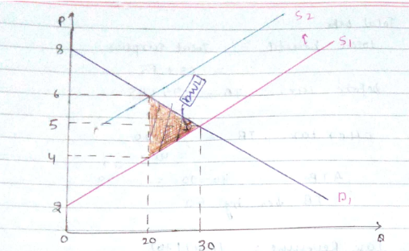
a) Before tax equilibrium tax and quantity are 5 and 30.
After the tax the supply curve shifts to the left from s1 to s2.
b) Quantity after tax Q_{tax} is 20
c) Pc =price paid by consumer=6
pp price received by producer=4
d) Cs before tax = 0.5(8-5) (30)
=45
Cs after tax =0.5 (8-6) (20)
=20
Cs= 20-45=-25

Therefore Cs area =25units
Cs $ =$25
Therefore Cs decreased by 25

Before tax Ps =0.5 (5-2) (30)
=45
After tax Ps = 0.5(4-2) (20)
=20
Ps = 20-45 =-25
Ps area =25units
Ps $=$25
Therefore Ps decreased by 25

e) Total benefit =total surplus
Total surplus =consumer surplus + producer surplus
Before tax TB: 45 +45 =90
After tax TB: 20+20 =40
TB= 40-90 = -50
TB area = 50 units
TB $=$50
Therefore TB decreases by 50

Total cost= 45-20
Therefore TC area=25units
TC $= $25

f) Tax revenue (6-4) (20)
2 x20 =40
Q_{tax} area=40units
Q_{tax} $ =$40

g) DWL = 0.5(6-4) (30-20)
=0.5 x 2 x 10
=10
DWL (Q_{tax}) area =10 units
DWL (Q_{tax}) $ =$10

